 **Project Report**

**Course Title: Physics Lab**

**Course Code: PHY 104**

**Project name: Rain Alarm Device**

**Submission date: 15 April, 2021**

|  |  |
| --- | --- |
| **Submitted to** | **Submitted by** |
| **Meherun Nesa**  **Lecturer**  **Dept. of EEE**  **Green University** | 1. **Joy Pal**   **Id: 201002418**   1. **Prothom Barman Rittik**   **Id: 203002030**  **Dept. of CSE**  **Green University** |

**Project Title:**

**Rain alarm device.**

**Objective:**

To buzz an alarm when it detect rain water.

**Theory:**

Rain Alarm is a device which is used to give the information is the rain is occurring as it gives sound when rain falls between the two aluminium rods. As the rain drop comes between the two rods the circuit gets completed and a sound is produced from the speaker indicating the falling of rain. It can be used in factories, open godowns where the goods need to be protected from rain. It can also be used as a water level indicator by fixing the two rods at desired level when water will reach that level it will automatically produce sound.

**Apparatus:**

1. **Rain sensor.**

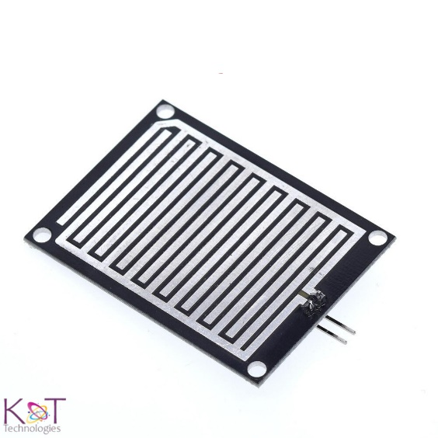

1. **n-p-n transistor BC547**

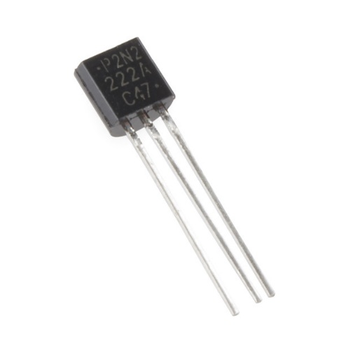

1. **Resistors (470, 100k and 1k ohm)**

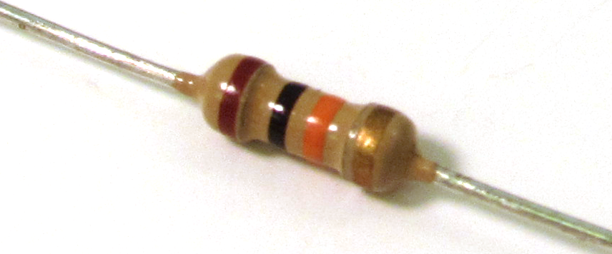

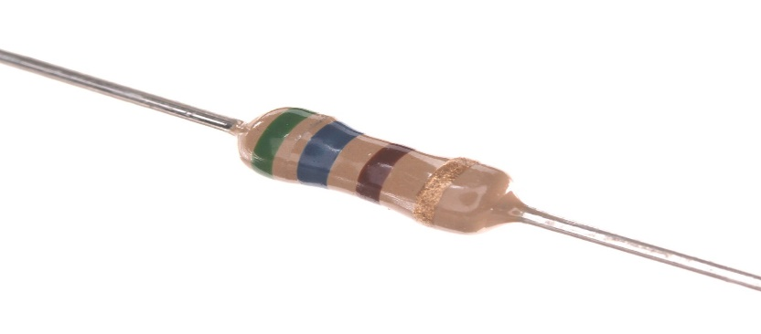

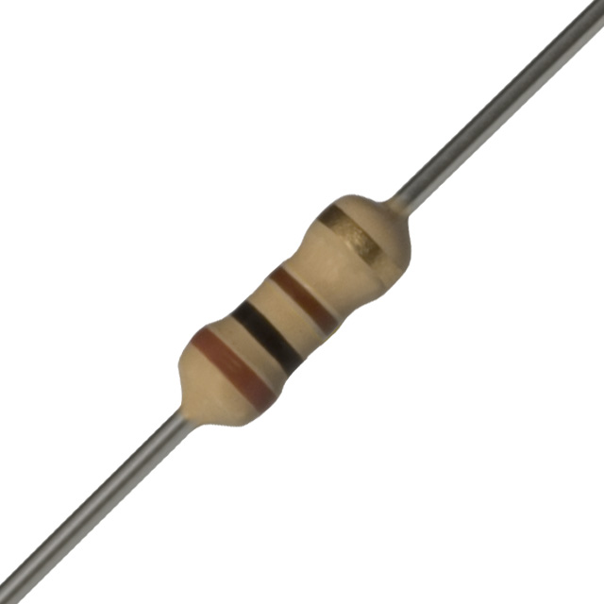

1. **Capacitor (10uf).**

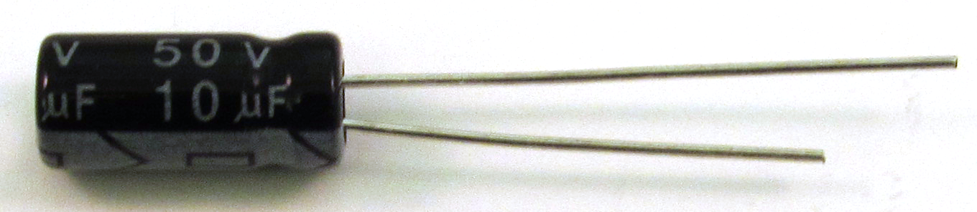

1. **Buzzer.**

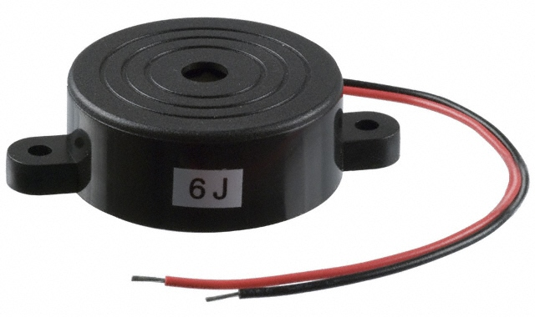

1. **Battery 9v.**

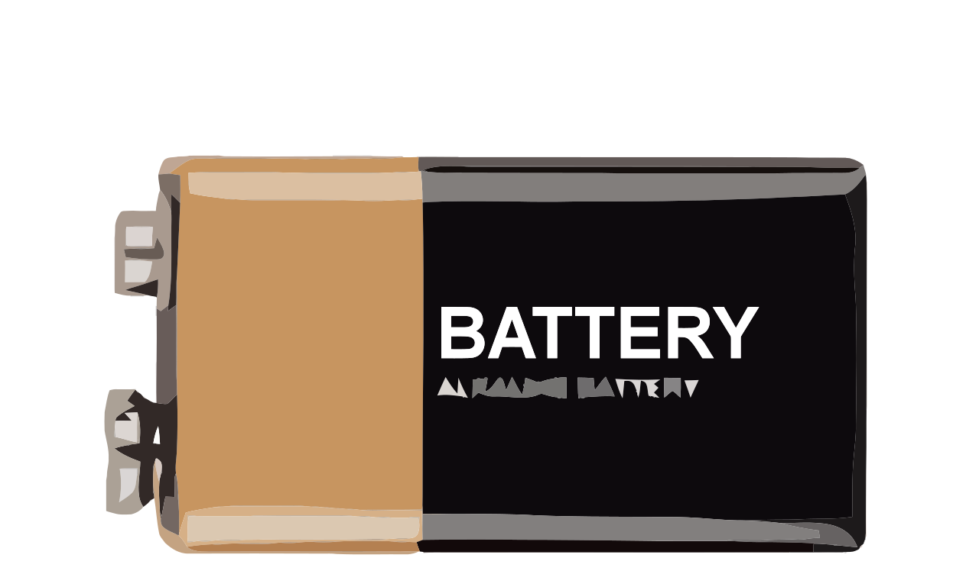

1. **Timer chip 555**

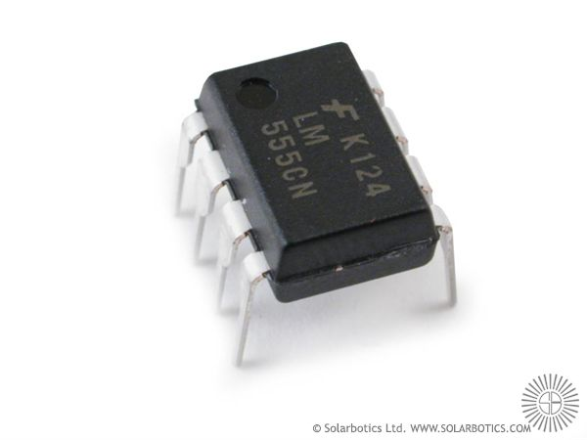

**n-p-n transistor:**

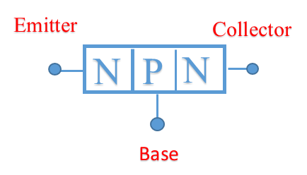 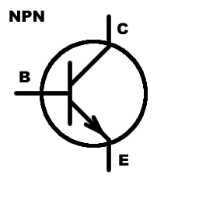

NPN transistor symbol

**N-P-N transistor have three state of operation**:

OFF state: In this state there is no base current applied or IB = 0.

ON active state: In this state any changes in IB will cause changes in IC.

ON Active: In this state any changes in I B will not cause changes in IC and IC will be nearly constant. This state cannot be used to run the transistor as a signal amplifier since the output signal will be clamped when transistor becomes saturate. Transistor in operating state when transistor is in OFF state, the voltage across collector and emitter terminal is equal to the supplied voltage, which is equivalent to the open circuit. When transistor is in saturation state, the collector to emitter is equal or less than 0.2 V, which is equivalent to the logical ‘0’and the saturation state is equivalent to the logical ‘1’.

**Circuit diagram:**

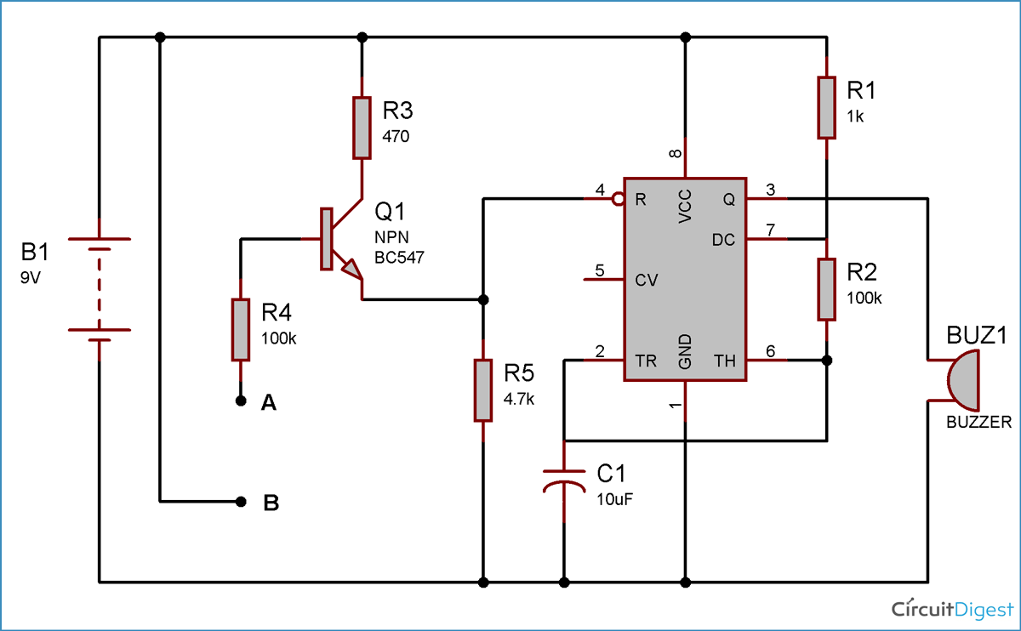

Working:

The points A and B of the circuit are connected to the points A and B of the rain sensor respectively. When rain is falling, the rain water will fall on the rain sensor which has aluminum wires on mica or Bakelite sheet. Due to the water on sensor, the aluminum wire ‘w’ develops resistance and gets conducted because of battery connector, the sensor and also to the circuit. When the aluminum wires are connected, the transistor Q1will get turned on and also Q2 will also be turned ON. When the Q2 is saturated, the capacitor C1 will be shorted and make the transistor Q3 to be turned ON. C1 will get charged by the resistor R4. The reset pin of 555timer which is connected to the emitter of Q3 will be made positive when Q3 reaches to the saturation mode. The 555 timer is configured in a stable mode. When the reset pin of the 555 timer is made positive because of saturation mode of Q3, it will generate the pulse at the pin 3 and make speaker to ring alarm. Capacitor is connected in between the pin 3 of 555 timer and speaker because to block the DC signal and allow only the variations in the signal which make the speaker to make sound. The diode D2 will not allow any reverse current from the timer. Because of the resistor R4 and capacitor C1, Q3 will get in cut- off after sometime and make the reset pin of 555timer in negative and speaker will stops making sound. The time for 555timer to make speaker sound depends on the values of C1 and R4. When there is no rain, the aluminum wire of the sensor will not have any resistance or conduction cannot trigger the circuit.

**Procedure:**

To connect the all components according to the above circuit diagram.

1. The positive terminal of 9V power supply is connect with 1k resistance, 100 ohm resistance and the positive terminal of the buzzer.
2. Then the rain alarm sensor’s one terminal connect to 100 ohm resistance and another terminal connect to the base of the n-p-n transistor.
3. The emitter of the transistor is ground and collector is connect in series to the negative terminal of buzzer.

**Rain Alarm Project Block Diagram:**

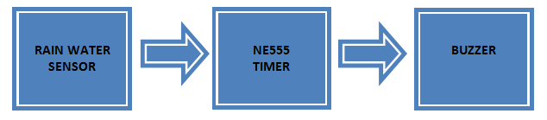

Rain water sensor is the main component in the circuit. For

this rain sensor, no need to go and buy in the market or

online. We can do it ourselves just by taking the piece of

Bakelite or mica board and aluminum wire. Bakelite or mica

board should be made completely flat and aluminum wire

should be pasted on the flat board as shown in the figure

below of rain water sensor. Care should be taken that there

should be no spaces between the wire and board. When the

rain water sensor is completed, it should get connected to

the circuit and voltage should be passed through the wires

Rain water sensor is the main component in the circuit. For

this rain sensor, no need to go and buy in the market or

online. We can do it ourselves just by taking the piece of

Bakelite or mica board and aluminum wire. Bakelite or mica

board should be made completely flat and aluminum wire

should be pasted on the flat board as shown in the figure

below of rain water sensor. Care should be taken that there

should be no spaces between the wire and board. When the

rain water sensor is completed, it should get connected to

the circuit and voltage should be passed through the wires

Rain water sensor is the main component in the circuit. For

this rain sensor, no need to go and buy in the market or

online. We can do it ourselves just by taking the piece of

Bakelite or mica board and aluminum wire. Bakelite or mica

board should be made completely flat and aluminum wire

should be pasted on the flat board as shown in the figure

below of rain water sensor. Care should be taken that there

should be no spaces between the wire and board. When the

rain water sensor is completed, it should get connected to

the circuit and voltage should be passed through the wires.

There is a block diagram of the rain alarm project is shown in the following image. The main components of the project are the rain water sensor, 555 timer IC and Buzzer.

Rain water sensor is the main component in the circuit. For

this rain sensor, no need to go and buy in the market or

online. We can do it ourselves just by taking the piece of

Bakelite or mica board and aluminum wire. Bakelite or mica

board should be made completely flat and aluminum wire

should be pasted on the flat board as shown in the figure

below of rain water sensor. Care should be taken that there

should be no spaces between the wire and board. When the

rain water sensor is completed, it should get connected to

the circuit and voltage should be passed through the wires

Rain water sensor is the main component in the circuit. For

this rain sensor, no need to go and buy in the market or

online. We can do it ourselves just by taking the piece of

Bakelite or mica board and aluminum wire. Bakelite or mica

board should be made completely flat and aluminum wire

should be pasted on the flat board as shown in the figure

below of rain water sensor. Care should be taken that there

should be no spaces between the wire and board. When the

rain water sensor is completed, it should get connected to

the circuit and voltage should be passed through the wires

Rain water sensor is the main component in the circuit. For

this rain sensor, no need to go and buy in the market or

online. We can do it ourselves just by taking the piece of

Bakelite or mica board and aluminum wire. Bakelite or mica

board should be made completely flat and aluminum wire

should be pasted on the flat board as shown in the figure

below of rain water sensor. Care should be taken that there

should be no spaces between the wire and board. When the

rain water sensor is completed, it should get connected to

the circuit and voltage should be passed through the wires

**Practical simulation of the project:**

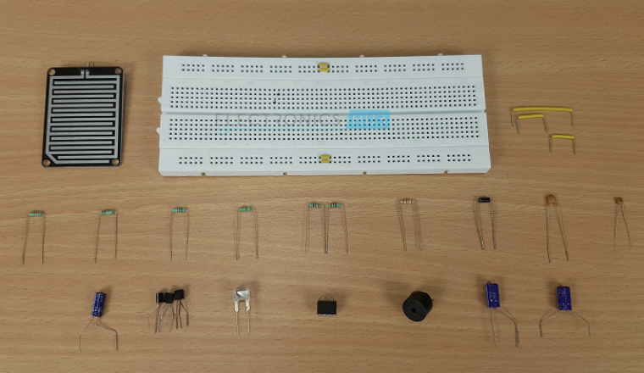

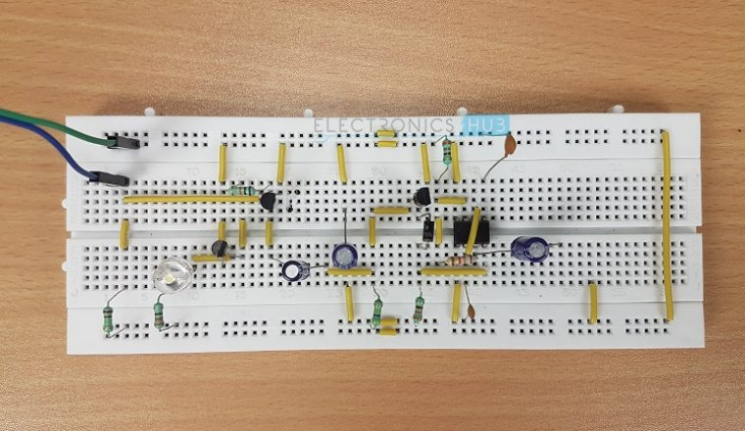

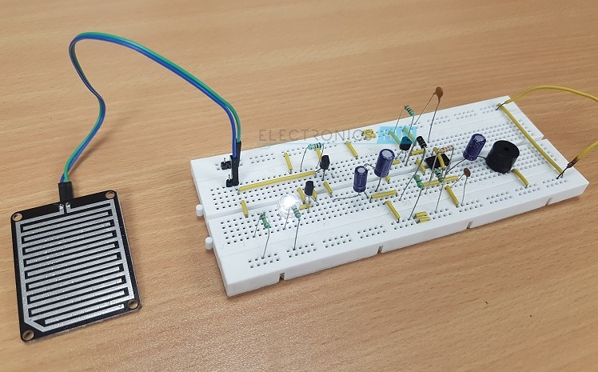

**Abstract and use of the project:**

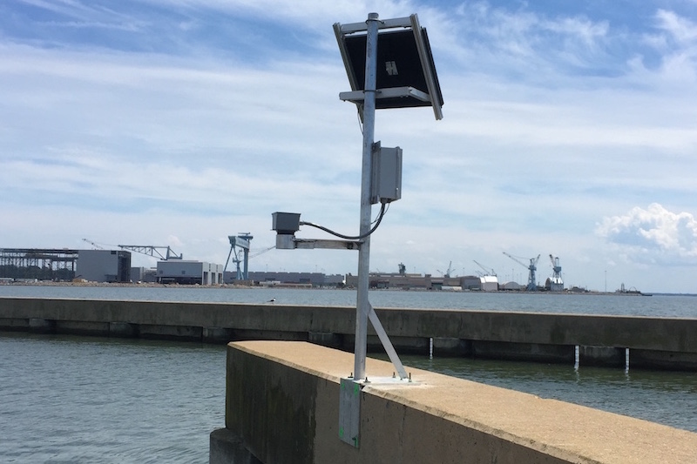

This project is entitled as “Rain Alarm with closing facility” used in home and cottage industries, open godowns etc . The main purpose of this project is to prevent the materials from rain. Using this project we can avoid the mental stress. These are special types of wipers that turn on automatically when it begins to rain and turn off when the rain stops. This is based on the versatile, multipurpose timer chip 555. The timer 555 is used in the monostable mode in the project. The sensor is connected between the trigger pin ground. The closing plates are connected with the relay when the rain starts the sensor will ON and plate closed. This project is also used in agricultural fields to detect rain and stop irrigation immediately. Home automation applications such as closing the windows and doors when raining outside.

**Advantages:**

* It is very cheap.
* The battery last very much.
* Not risky.
* No harmful effect.

**Disadvantages:**

* It doesn’t tell about the speed of rain which is fallen on the roof.
* It will send signal until the detector becomes wet.

**Application:**

1. In the irrigation, it will detect the rain which is fallen on the roof.
2. It automobiles, when the rain detector detects the rain it will immediately active the wiper and inform the driver.

**Conclusion:**

It is very cheap to make. This circuit help us to alarm from the rain. The circuit set’s in the laboratories, scientific society centers etc. The water sensor is set on the roof and when the rain water fall on it, the buzzer start beeping. By designing this circuit we can check the level of water.

**The End**